CST 326 – Game Development

Project 2 - Shoot ‘em up (Part 1)

California State University Monterey Bay

Objective:

This week we are going to start keeping track of information happening in the game (high score) and start working with bullets. We are increasing the complexity of our game by going against an enemy alien horde.

SUBMISSION: FORMAT AND RULES

(Part 1) You have until Sunday, 11:59:30 PM to upload your solution for Project 2b. “Uploading” consists of sending the URL for your Git repository (if it’s public you don’t have to add me).

(Part 2) Upload the link from your screen captured video (should be an ‘unlisted’ video in YouTube in your profile) with you explaining your code (should be <5 minutes).

The total value of this activity: 40 bonus points

Implement the following in your game:

(10 Points) Implement the GUI on the of the picture below and keeps track of the score of the player. The high score for that session will need to be implemented as well.

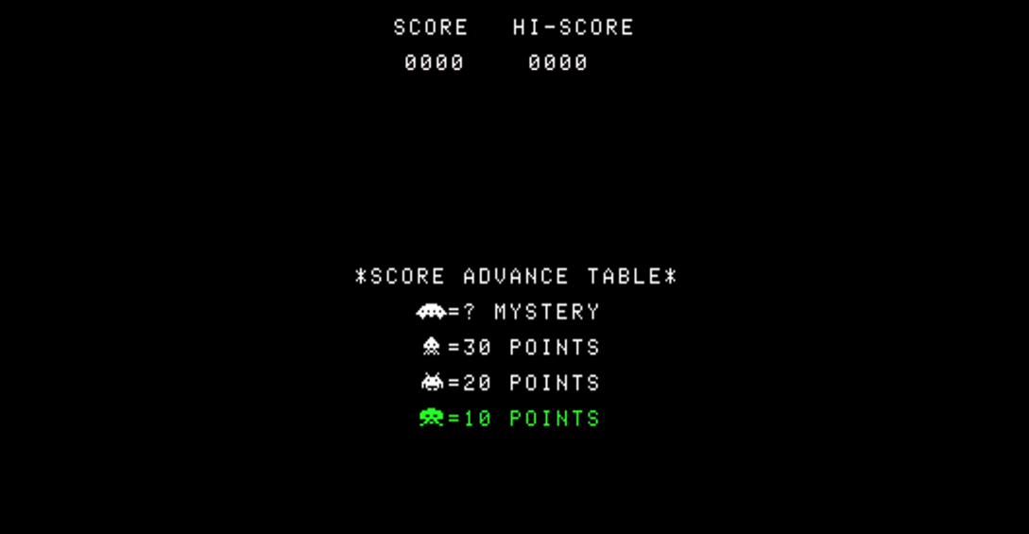

* (+ 3 points) Keeping track of the current score
* (+ 5 points) Keeping track of the session’s high score (if you restart the app it goes back to 0)
* (+ 2 points) Format the string of numbers to give leading zeros when the score hasn’t gotten there yet (i.e., 0040 vs 40).

(10 Points) Implement a scoring system (can be the one featured above) that has different values depending on the enemy that you kill (4 different types).

* (+ 2.5 Points) for each for a maximum of 10 points

(10 Points) Implement a logic either exactly or similar to space invaders. The enemies are on a continuous path towards intercepting the player, the enemy (as a group) speeds up when there are fewer enemies as you destroy them with your bullets, and you have a barricade that gets smaller in size as bullets hit it.

* (+ 2 points) Enemies continuous travel towards the player (not directly straight at the player)
* (+ 2 points) Enemies as a group speed up as more are destroyed
* (+ 2 points) Your bullets destroy the enemy and your barricade if you hit it
* (+ 2 points) Enemies periodically fire bullets that kill you (right now it can be any enemy on the screen, next week we’ll make it specifically certain ones)
* (+ 2 points) Enemies bullets can destroy your barricades

(10 Points) Talking Through your project

* Talk about your project, point by point in the formats discussed in class